Selenium Grid – How to Easily Setup a Hub and Node

In the previous chapter, we got to know about [***What is Selenium Grid***](http://toolsqa.com/selenium-webdriver/selenium-grid/), its benefit and it’s architecture. In this chapter, we will learn to use Grid and go through the process of***Selenium Grid – How to Easily Setup a Hub and Node***

* ***First, configure the hub.***
* ***Secondly, configure the nodes.***
* ***Then we will develop the script and execute***

### Step 1: Download Selenium Server and Set up GRID Hub

1. Download the latest Selenium Server file from [***http://docs.seleniumhq.org/download/***](http://docs.seleniumhq.org/download/)***.***

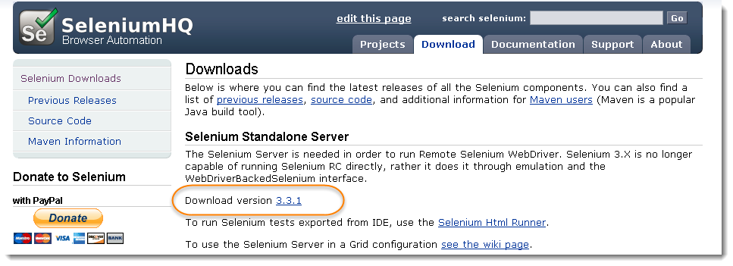

2) You can place the ***Selenium Server jar*** file anywhere in your hard drive. But for the purpose of this tutorial, place it on the ***C: Drive*** of ***Hub Machine.***After doing this, you are now done installing Selenium Grid.

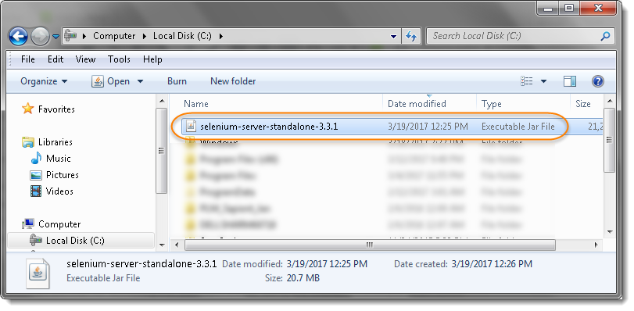

3) We are now going to launch a hub. Open command prompt and navigate to the ***C: Drive***, because that is the directory where we placed the Selenium Server. On the command prompt, type***java -jar selenium-server-standalone-3.3.1.jar -role hub***

*Commands says that start the Selenium Server and give it a Role of Hub*

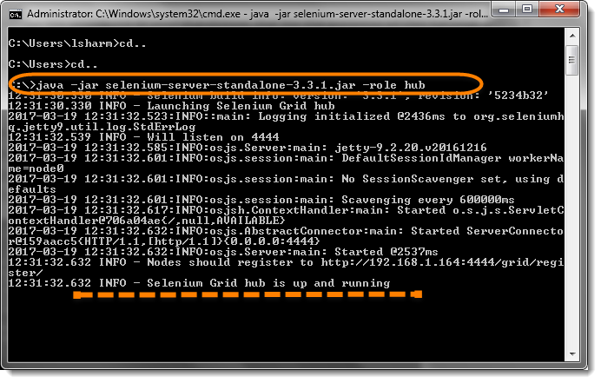

***Note****:*

* *Make sure you change the version number from the command accordingly.*
* *Your Grid server will up and running till the time command prompt window is opened, if you close it, that will also stop the selenium server.*
* *Selenium Grid, by default uses port 4444 for its web interface. To start the same on other port, use this command:****java -jar selenium-server-standalone-3.3.1.jar -port 4455 -role hub***

The hub will be launched and command prompt should look similar to the image below

3) To verify whether hub is running, open the browser and navigate to [***http://localhost:4444***](http://localhost:4444/)

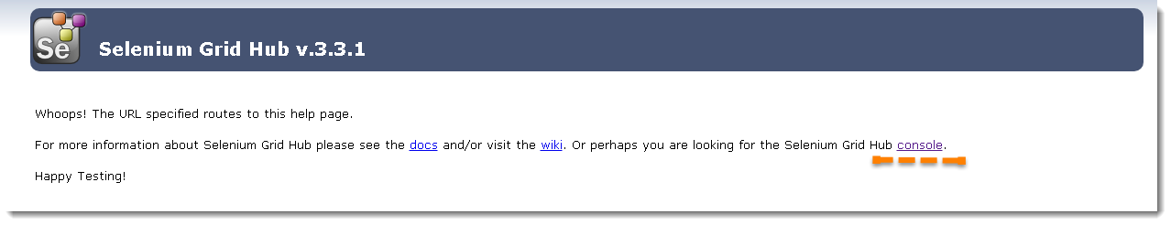

Console gives the information what is available on the Hub. As of now it will be blank, as there is no machine connected to it.

4) Now click the ***Console*** link and then click ***View Config***. The config of the hub would be displayed like this:

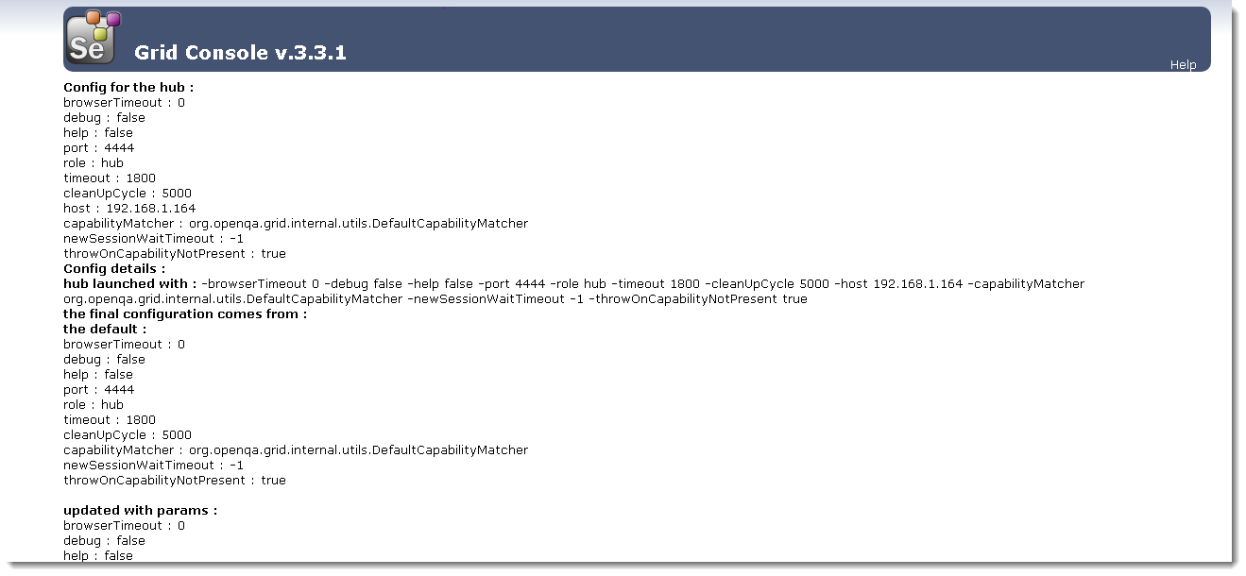

3) Open Command Prompt. If you are setting up Node on different machine, log on to that machine and open Command Prompt.

4) To register Hub Machine with Node Machine, type;

***java -jar selenium-server-standalone-3.3.1.jar -role node -hub http://192.168.1.164:4444/grid/register -port 5555***

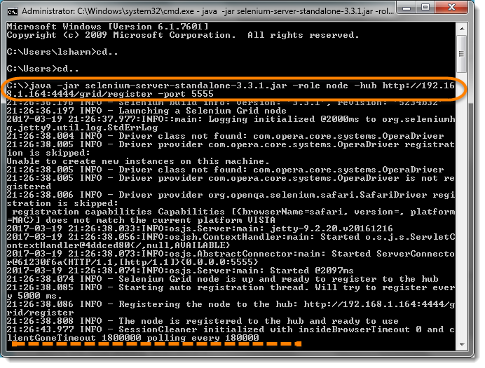

4) After executing the command then return to the Hub and navigate the URL http://localhost:4444 or http://192.168.1.164:4444 and the hub will now display the node which is attached to it.

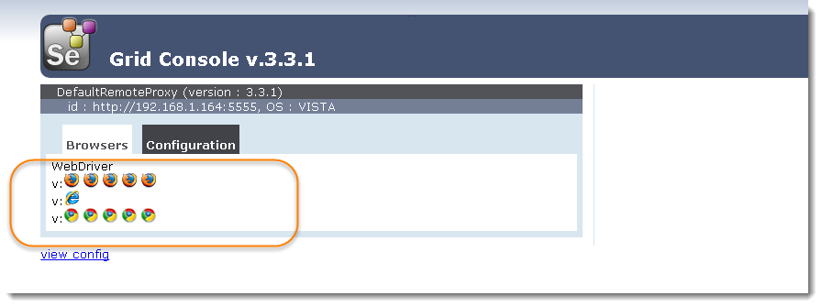

***Note****: The above Console page gives the information about the Node Machines, which all are connected to the Hub. It provides the information about the Node Machine IP Address, OS Type, Browsers etc. You will find 5 Chrome, 5 Firefox and 1 IE browser under Browser section like above. This indicates that by default you can use 5 Chrome, 5 Firefox and 1 IE browser.*

In case of more machines attached, you would see more block on the Console Page.

### ***Step 3 : Write a Test Script***

Below is a simple WebDriver code that you can create in Eclipse. Once you run it, automation will be performed on Node Machine.



|  |  |
| --- | --- |
| 1  2  3  4  5  6  7  8  9  10  11  12  13  14  15  16  17  18  19  20  21  22  23 | import org.openqa.selenium.WebDriver;  import org.openqa.selenium.remote.DesiredCapabilities;  import org.openqa.selenium.remote.RemoteWebDriver;    import java.net.MalformedURLException;  import java.net.URL;    public class Grid_SetUp {  public static WebDriver driver;    public static void main(String[]  args) throws MalformedURLException, InterruptedException{    String URL = "http://www.DemoQA.com";  String Node = "http://192.168.1.164:4444/wd/hub";  DesiredCapabilities cap = DesiredCapabilities.firefox();    driver = new RemoteWebDriver(new URL(Node), cap);    driver.navigate().to(URL);  Thread.sleep(5000);  driver.quit();  }  } |

### ***Explanation***

1) The URL will be***IP Address*** of ***Hub Machine*** + Hub ***Port***+ ***/wd/hub*** = ***“http://192.168.1.164:5555/wd/hub”;***

2) ***RemoteWebDriver***accepts the ***RemoteAddress***which is of type ***URL***and it also accepts the ***Desired Capabilities***.

***WebDriver driver = RemoteWebDriver(new URL(Node), cap);***